Brett Worley
CEG-3110-01
Project 3

From homework 6, I will include the code section and the resulting graph for ease of use for creating the paths through the graph. With these, we will create paths to achieve statement , branch, and path coverage. After making the coverage paths, we will then look through the project 2 test plan and check to see which cases follow the same path.

int chk_forward(const char* new_pass, int newlen, int new_index,
const char* old_pass, int oldlen, int old_index)
{
int i;
int same = FALSE;
int count = 1;
A
const int substrlen = 5;
new_index++; old_index++;

for(i = 1; i < substrlen; i++) {
B

if((isalpha(new_pass[new_index])) &&
C
C
(isalpha(old_pass[old_index]))) {
if(lettercmp(new_pass, new_index, old_pass,
D
old_index)) {
count++;
E
} else {
count = 1;
F
}
} else {

if(!strncmp(&new_pass[new_index],
G
&old_pass[old_index], sizeof(char))) {
count++;
H
} else {
count = 1;
I
}
}
old_index = (old_index + 1) % oldlen;
J
new_index = (new_index + 1) % newlen;
}

if(count >= 5) {
K
same = TRUE;
L
}

return same;
M
}
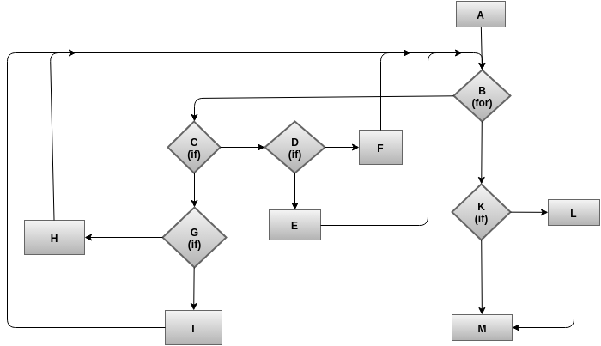

Statement Coverage

ABCDEBCDFBCGHBCGIBKLM

This was path is not traversed by any test cases. This is caused by the path going through and resetting the count of the total number of similar characters, but then still go through the statement that the password is similar to.

Branch Coverage

ABCDEBKLM

This path was traversed by test case 1:

New Password: SsaPmis628@@
Current Password: #558#&;DoGs
Previous Password: SimPass12!!

ABCDFBKM

This path was traversed by test case 10:

New Password: 77WaitT!=gge
Current Password: ˆ002raceCAR,
Previous Password: FoolIng112=!

ABCGHBKLM

This path was traversed by test case 12:

New Password: ;:03FIres10001
Current Password: Snake8,2Dl
Previous Password: 234+.;Serifant

ABCGIBKM

This path was traversed by test case 10:

New Password: 77WaitT!=gge
Current Password: ˆ002raceCAR,
Previous Password: FoolIng112=!

ABKLM

This path is not possible, as to reach the function, the password must be a valid length. The for loop must be gone through as it goes through the length of the password, therefor it must be traversed.

ABKM

This path is not possible, as to reach the function, the password must be a valid length. The for loop must be gone through as it goes through the length of the password, therefor it must be traversed.

Path Coverage

ABCDEBCGIBKLM

This was path is not traversed by any test cases. This is caused by the path going through and resetting the count of the total number of similar characters, but then still go through the statement that the password is similar to.

ABCDFBCGHBKM

This path was traversed by test case 10:

New Password: 77WaitT!=gge
Current Password: ˆ002raceCAR,
Previous Password: FoolIng112=!

ABCGHBKM

This path was traversed by test case 10:

New Password: 77WaitT!=gge
Current Password: ˆ002raceCAR,
Previous Password: FoolIng112=!

ABCGIBKLM

This was path is not traversed by any test cases. This is caused by the path going through and resetting the count of the total number of similar characters, but then still go through the statement that the password is similar to.

ABCDFBKLM

This was path is not traversed by any test cases. This is caused by the path going through and resetting the count of the total number of similar characters, but then still go through the statement that the password is similar to.

ABCDEBKM

This path was traversed by test case 10:

New Password: 77WaitT!=gge
Current Password: ˆ002raceCAR,
Previous Password: FoolIng112=!

